
Jayanth Reddy
jayanthreddy003@gmail.com
469-647-9834

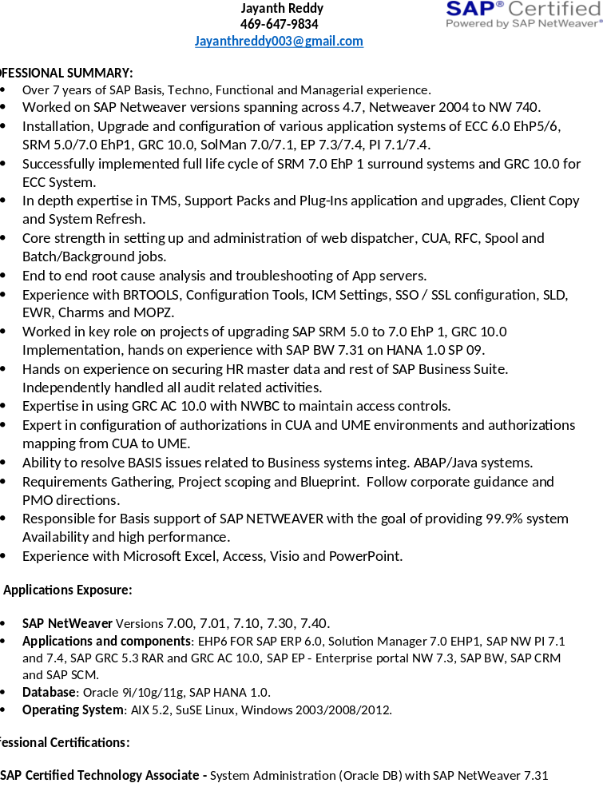
PROFESSIONAL SUMMARY:
      - Over 8+ years of SAP Basis, Techno, Functional and Managerial experience.
- Worked on SAP Netweaver versions spanning across 4.7, Netweaver 2004 to NW 740.
- Installation, Upgrade and configuration of various application systems of ECC 6.0 EhP5/6, SRM 5.0/7.0 EhP1, GRC 10.0, SolMan 7.0/7.1, EP 7.3/7.4, PI 7.1/7.4.
- Successfully implemented full life cycle of SRM 7.0 EhP 1 surround systems and GRC 10.0 for ECC System.
- In depth expertise in TMS, Support Packs and Plug-Ins application and upgrades, Client Copy and System Refresh.
- Core strength in setting up and administration of web dispatcher, CUA, RFC, Spool and Batch/Background jobs.
- End to end root cause analysis and troubleshooting of App servers.
- Experience with BRTOOLS, Configuration Tools, ICM Settings, SSO / SSL configuration, SLD, EWR, Charms and MOPZ.
- Worked in key role on projects of upgrading SAP SRM 5.0 to 7.0 EhP 1, GRC 10.0 Implementation, hands on experience with SAP BW 7.31 on HANA 1.0 SP 09.
- Hands on experience on securing HR master data and rest of SAP Business Suite. Independently handled all audit related activities.
- Expertise in using GRC AC 10.0 with NWBC to maintain access controls.
- Expert in configuration of authorizations in CUA and UME environments and authorizations mapping from CUA to UME.
- Ability to resolve BASIS issues related to Business systems integ. ABAP/Java systems.
- Requirements Gathering, Project scoping and Blueprint. Follow corporate guidance and PMO directions.
- Responsible for Basis support of SAP NETWEAVER with the goal of providing 99.9% system Availability and high performance.
- Experience with Microsoft Excel, Access, Visio and PowerPoint.

SAP Applications Exposure:

- SAP NetWeaverVersions7.00, 7.01, 7.10, 7.30, 7.40.
- Applications and components: EHP6 FOR SAP ERP 6.0, Solution Manager 7.0 EHP1, SAP NW PI 7.1 and 7.4, SAP GRC 5.3 RAR and GRC AC 10.0, SAP EP - Enterprise portal NW 7.3, SAP BW, SAP CRM and SAP SCM.
- Database: Oracle 9i/10g/11g, SAP HANA 1.0.
- Operating System: AIX 5.2, SuSE Linux, Windows 2003/2008/2012.

Professional Certifications:

- SAP Certified Technology Associate - System Administration (Oracle DB) with SAP NetWeaver 7.31

PROFESSIONAL TRAININGS:
- SAP Basis training including Troubleshooting and Performance tuning for ABAP and JAVA Stack.
- Oracle database administration training by National Institute of Information Technology.

EDUCATION:
- B Tech in Electronics from JNTU, Hyderabad, India.

Client:American Hotel,Vernon Hills, IL. Oct2015 – Present
Role: SAP Basis Administrator
- Provided BASIS Administration support for multiple projects utilizing ECC on UNIX with Oracle Platform.
- Performed OSS user administration, maintained developer and object keys and OSS service connections.
- Installed Solman 7.1 and performed post installation to include basic configuration SLD, LMDB, managed system.
- Support Pack upgrade from SP00 to SP11.
- Initial Configuration setup SOLMAN_SETUP phase for solution manager 7.1.
- RFC Connection created for satellite systems.
- Xml file generation for system upgrade.
- Updating solution / product system / product version in Solman SLD.
- Configured Early watch Alerts.
- Involved in installation and sizing of SAP HANA on BW NW 7.31.
- Involved in initial configuration phase of HANA DB.
- Performed post HANA client upgrade to revision 97.
- Installed SAP HANA on VMware based Linux OS virtual system.
- Involved in Sizing of SAP HANA.
- Transportation of Catalogue Objects and Content Objects.
- Performed transports through delivery units.
- Configured auto-log backups.
- Involved in System refresh of PRD – QTY.
- Performed ESS/MSS configuration including setting up of Java Connector (JCo) connections to the J2EE server with ESS/MSS Business Packages, setting up connections between ABAP and JAVA stacks.
- Experience in SAP Portal OSS notes, Components deployment and was handling any kind of issues related to Enterprise Portal and troubleshooting.
- Configured Maintenance Optimizer to download software’s from SAP Service Marketplace.
- Downloaded SAP router files, installed and configured to connect with SAP service Marketplace.
- Created RFC connection and configured all child systems to connect with SAP ECC 6.0 and vice versa.
- Resolved issues during system configuration and SAP Router configuration.
- Configured Transport Management System (TMS) in three – system landscape for SAP ECC,
- Upgraded ST-PI and ST-A/PI Software components for ECC 6.0, SRM, SCM, APO and BI Systems.
- Configuration of SSO in Enterprise portal system for connecting to Abap systems without password authentication.
- Configuration of Web dispatcher for Enterprise Portal, ECC, BI systems.
- Utilized web dispatcher configurations of Abap systems in SSO configuration for ease of load distribution from Enterprise portal system to Abap systems.

Client: MillerCoors,Milwaukee, WI. Jan 2015 – Sept 2015 Role: SAP Basis Administrator

- Registered and configured satellite systems in Solution Manager as Managed System.
- Administrated SLD instances for both Non-PROD and PROD systems.
- Configured SLD data supplier for all the systems to connect with SLD.
- Monitored and administrated PI communication channelsthrough NWA and helped resolving issues.
- Logon Groups configuration and monitoring the load distribution.
- Batch Server Configurations and Monitoring.
- Spool Servers Configuration and Monitoring.
- Enqueue Server Administration and Monitoring.
- Monitoring OLD system Locks.
- Inbound & Outbound various queues monitoring.
- IDOCs process monitoring between business systems.
- Monitoring OLD system Locks.
- Performing Workload analysis of SAP System like DIA/BTC/HTTP response times.
- Configured Single Sign-On (SSO) from SAP EP to SAP ECC, SRM SUS & EBP and C – Folder system.
- Scheduling & monitoring standard and customized Background Jobs.
- Involved in Managing / configuring application Server with profile parameters.
- Deployed SAP Web Dispatchers for ABAP system and configured System objects in portal with web dispatcher links for better load distribution.
- Deployed SRM EBP / MDM components on Enterprise portal system.
- Configured Web dispatcher for SRM Java portal – connecting from SAP NW EP.
- Centralized the authorizations provisioning through 2 core concepts, mounted JAVA system UME on ECC and maintained ECC as CUA central system.
- SAP Web-Dispatchers Installation and Administration.
- Setup PROXY configuration for all SAP Landscape.

Environment: SAP HANA 1.0 SPS 97, Oracle 11.2, AIX6.3, SUSE Linux 11, Windows2012 R, NW7.3/7.4, SAP ECC 6.0 EhP 7, BI 7.3/7.4, PI 7.11, APO 703 , BPC 10.0, CRM 7.0,HCM 6.04, OER 7.1,SCM 7.0, SLT 7.3, SRM 7.0, SAP BO, Solution Manager 7.1 Remedy, SAPHANA Studio.

Dr. Reddys Laboratories, Hyderabad, India. SAP Basis Administrator

Dr. Reddy’s is an integrated global pharmaceutical company, committed to providing affordable and innovative medicines for healthier lives. Through three core businesses: pharmaceutical services and active ingredients, global generics and proprietary products. The business markets its products worldwide with a particular focus on India, the United States and Russia.

Project: e-Invoicing - SAP SRM Upgrade from 5.0 to 7.0 Aug 2014 – Jan 2015

- Deployed SAP NW 7.4 C-folder and SAP NW 7.4 Java Systems.
- Involved in upgrade of SRM system 5.0 to 7.0 on NW 7.4.
- Maintenance, Starting and Stopping of MDMSystem.
- Portal User Management Engine mounted on ECC ABAP System.
- Configured two way RFCs connecting SRM - PI - ECC - CF.
- Configured CUA for SRM – ECC – CFolders systems in DEV, QTY & PRD environments.
- Configured SSO between EP JAVA - SRM ABAP System.
- Configured SSO between EP JAVA - SRM JAVA System.
- Configured FPN between EP and SRM portal.
- Administering New surround system for SRM - MDM Catalogue System.
- Setup One time PROXYconfiguration between ECC - PI - SRM for various interfaces connecting between systems in DEV, QTY & PRD Environments.
- Oracle Upgrade SBP patch-level from 11.2.0.1.8 to 11.2.0.3.10 on Linux/winR12 OS.
- Configured TMS with best SAP practice - Three system Landscape for SRM SUS / EBP, C – Folder systems.
- Deployed SAP Web Dispatchers for ABAP system and configured System objects in portal with web dispatcher links for better load distribution.
- Deployed SRM EBP / MDM components on Enterprise portal NW 7.4 system.
- Configured Web dispatcher for SRM portal - connecting from SAP EP 7.0.
- Centralized the authorizations provisioning through 2 core concepts, mounted JAVA system UME on ECC and maintained ECC as CUA central system.
- Designing End to End authorizations in SUS – EBP, C- Folders and MDM catalogue systems for supply chain team, vendors and finance team respectively.
- Involved in Validation / Cut-over / Go-Live and Hypercare support.
- Provided extended support on Go-Live issues.

Project: Applications Lifecycle Management - SAP Solution manager upgrade 7.0 to 7.1. May ’14 – July ‘14

- Deployed SAP Solution manager system 7.1.
- Support Pack upgrade SP00 to SP11.
- Initial Configuration setup SOLMAN_SETUP phase.
- RFC Connection created for satellite systems.
- Xml file generation for system upgrade.
- Updating solution / product system / product version in Solman SLD.
- Configuration of Early watch Alerts.
- Configuration of Maintenance optimizer.
- Updated Solution Manager System from 7.0 to 7.0 EHP1. Configured Solution Manager for SAP project implementation, RCA, EWA, SMD, MOPZ and Central system monitoring.

Project: Internal Audits - SAPGRC upgrade from 5.3 to 10.0 Jan 2014 – April 2014

- End to End Configuration of GRC 10.0 - EAM. Maintained ECC as business system.
- Configured Email for required GRC alerts.
- New Reason Code creation and Updating for EAM.
- Scheduled a Background Job to Receive Log Messages.
- Creating and Mapping FF ID’s and FF Owners and Controllers.
- Distribution Fire Fighter monthly Log Summary to Controllers.
- Maintaining SAP Access Control Risk Analysis Configuration Parameters.
- Defining Connector to the AUTH Scenario.
- Uploading Risk and Activation.
- Scheduling Synchronization Batch Jobs for Roles, Profiles and users sync.
- Restoring Vanilla Rule Set with GRC 5.3 Rule Set.
- Simulating the addition of transactions, Roles, or Profiles to a User ID.
- Involved in Validation / Cut-over / Go-Live and Hypercare support.

Netweaver Day to day Support - SAP Netweaver Administration Jan 2011 – Dec 2013

- Administering Solution Manager – Service desk support tool 4.0, documenting and analysing all SAP Tickets.
- Circulate weekly report of pending, long lasting tickets and completed tickets with SLA status to ERP Head.
- Administering SAP NW Process Integration System 7.1 and 7.31.
- SAP Web-Dispatchers Installation and Administration.
- Setup PROXY configuration for all SAP Landscape.
- Performed Kernel Upgrades on Windows/Linux/AIX operating systems.
- Check for installation number specific to SAP System in SMP, download and apply license to systems.
- Involved in ABAP stacks System copy.
- Applying ABAP Support Packages on ECC 6.0 EhP6/SRM 7.0 systems.
- Applying JAVA support packages using SUM tool.
- Implementing SAP Notes using SNOTE, took help of abap consultant for program related issues.
- STMS Route configuration in the three-system landscape and request for Exports & Imports and trouble shooting in the transport management system.
- Instance Profile activation and parameter changing, work process calculation and configuration using the Profile maintenance and settings T code RZ10.
- Change & Transport Management configurations & execution of transports as per schedule.
- Daily production imports. ABAP systems checklist preparation.
- Logon Groups configuration and monitoring the load distribution.
- Scheduling standard and customised business related Background Jobs and monitoring the custom based jobs status and troubleshooting the cancelled background jobs.
- Monitoring System Logs, Work Process Overview, Lock Entries, Update Errors.
- Spool Servers Configuration and Monitoring.
- Enqueue Server Administration and Monitoring.
- Monitoring OLD system Locks.
- Inbound & Outbound various queues monitoring.
- IDOCs process monitoring between business systems.
- Monitoring Workload analysis of SAP System like DIA/BTC/HTTP response times.
- Sending of system information to Central SLD using SLD data-pump.
- Scheduling & monitoring standard and customised Background Jobs.
- Involved in Managing / configuring application Server with profile parameters.
- RFC Administration and Monitoring.
- SAP Remote & local client copies before performing System copies.
- Performing Kernel upgrades for DEV and Quality systems.
- Applying Java Support Packages.
- Defining and Maintaining Operation Modes.
- Installing Business packages on Java Stack.
- System landscape directory – SLD Administration
- Java Central locks Management and administration.
- PI – Java - Communication Channels Monitoring.
- PI – Java – alerts monitoring.
- Monitoring overall Java System performance from /nwa.
- RFC Destinations / JCo’s creation between ABAP-JAVA Systems.
- Creating System objects under System Landscape for integrating into portal.
- Tablespace Administration, through BR* Tools.
- Monitoring Tablespace Incremental size and updating growth timely for records.
- Oracle Database online & Archive logs backup planning, execution and monitoring.
- DB free and utilized space monitoring.
- Monitored system with SM51, SM59, SM12, SM13, DB02, ST22, SM21, SM66 and Disk space monitoring and took appropriate action.
- Generated the stack xml via Maintenance Optimizer. Deployed support pack stack on ECC via SPAM/SAINT and NW EP 7.0 via SUM.
- Configured Load balancing with multiple dialog instances and performed workload analysis.
- Performed daily system monitoring including system logs/trace and lock entries.
- Investigated issues, did root cause analysis and raised OSS message in Service Market Place.

Environment: SAP NetWeaver 7.00, 7.01 7.10, 7.30, 7.41 Platforms with ECC 6.0 –Ehp5& EhP6, PLM 4.0, SEM 6.0, BI 7.0, EP 7.0 & 7.3, SCM 7.01 incl Live Cache, CRM 5.0, SRM 5.0& 7.0 EhP1, SAP NetWeaver Mobile 7.1, SAP PI7.1, SAP CE 7.2, SAP Content 6.30, SAP TREX 7.0 and SAP E-Recruitment 6.05,SAP Solution Manager 7.0 Ehp1, BOBJ 4.0, NAKISA 3.0.

RCI (Research Centre of Imarat) DRDO, Hyderabad, India. Jun 2009 – Dec 2010
Jr. SAP Basis Administrator

Research Centre Imarat, the premier institution of Defence Research &amp; DevelopmentOrganization (DRDO) has been established to design and develop world class, state-of- the-art technologies which will produce precise and reliable indigenous weapon systems tostrengthen country’s Armed Forces. RCI is pursuing research on Navigation, Control &amp;Guidance, Imaging Infrared &amp; Radio Frequency seekers, batteries and flight instrumentationtechnology areas. The other technology areas include Electrical and Mechanical Integrationof systems and Reliability and Quality Assurance. RCI has also set up Environmental andEMI/EMC test facilities for Qualification and Acceptance testing of the mechanical and electrical airborne hardware.

- New SAP User ID’s creation.
- Generated access keysand register key generation based on object ID in SMP.
- New SAP Roles, parent / child / composite / single roles creation.
- Design, developing and Implementing SAP Security Roles, Profiles and Authorizations for ECC system for various modules like FICO, MM, PP, QM, SD, HR using Profile generator.
- Position Based Authorizations provisioning & de-provisioning.
- Maintaining all authorisations for users in ECC centrally for entire landscape categorizing like DEV - QTY - PRD.
- Discovering Conflicts for new authorization in GRC 5.3 Risk Analysis Remediation.
- Creating custom authorization Objects for Non-Standard security needs of Reports.
- Maintaining temporary access from direct table access, program execution access & function modules.
- On demand provisioning of Table specific limited authorizations including DEBUG.
- Weekly review separated employee IDs and delete SAP User IDs.
- Periodic system critical transactions review against SOX needs.
- Performing Daily Health Checks of the SAP systems in the Landscape and Daily
Administrative tasks which include frequently monitoring system logs, work process,lock entries, update etc.
- Monitoring the background jobs and their status.
- Monitoring the work process overview and active servers.
- Monitoring the system logs and ABAP dumps and to make the corrective action.
- Monitoring the system trace, logged users locally and globally.
- User administration like creating, deleting, locking and unlocking the users.
- Analysing the missing authorization and make the corrective actions.
- User creation and assigning single Roles, composite Roles to users.
- Performed role comparison between quality and development systems.
- Transport the transport request from one system to other system.
- Performed kernel upgrades in landscape.
- Analysed different transport log files to troubleshoot transport problems.
- Starting and stopping the SAP Systems.
- Involved in applying Support Packages and Performed Kernel Upgrade.
- Creating single users and mass users as per client requirements.
- Based on the approval from role owner and assigned roles to users.
- Reset the passwords for locked users.
- Analysing cancelled jobs by using job logs.
- Provided end user support on authorisation issues using SU53, SUIM.
- To resolve runtime issues consulted functional and technical consultants.
- Locking and unlocking Users.
- Configuring Login Security with Restricted Password.

Environment:SAP R/3 4.7, ECC 6.0, Oracle 10.2, MS SQL 2005, Win 2003, Win 2008.

